

**CERTIFICATE**

This is to certify that the report entitled **“Encryption Decryption Application”** is a bonafied work carried out by **Mr. Tapas Vashi (16IT143)** under the guidance and supervision of **Prof. Kamlesh Makwana** for the subject **Software Group Project-3 (IT350)** of 6th Semester of Bachelor of Technology in **Information Technology** at Faculty of Technology & Engineering – CHARUSAT, Gujarat.

To the best of my knowledge and belief, this work embodies the work of candidate themselves , have duly been completed, and fulfills the requirement of the ordinance relating to the B.Tech. Degree of the University and is up to the standard in respect of content, presentation and language for being referred to the examiner.

|  |
| --- |
| Under supervision of,  **Prof. Kamlesh Makwana**  Assistant Professor  Dept. of Information Technology  CSPIT, Changa, Gujarat. |
| **Prof. Parth Shah**  Head & Associate Professor  Department of Information Technology  CSPIT, Changa, Gujarat. |

**Chandubhai S Patel Institute of Technology**

At: Changa, Ta. Petlad, Dist. Anand, PIN: 388 421. Gujarat

**TABLE OF CONTENTS**

**Acknowledgement 4**

**Abstract 5**

**Chapter 1 Introduction 7**

1.1 Project Summary 7

1.1.1 Purpose….……………………………………………………………………...7

1.2 Scope 7

1.3 Objective 7

**Chapter 2 System Requirements Study 8**

2.1 User Characteristics 8

2.2 Tools & Technology Used 8

**Chapter 3 System Design 9**

3.1 Project Flow 9

**Chapter 4 Implementation Planning 10**

4.1 Implementation Environment (Single vs Multi user, GUI vs Non GUI) 10

4.2 Coding Standards 10

4.3 Snapshots of project 14

**Chapter 5 Limitations and Future Enhancement 17**

**Chapter 6 Conclusion 18**

**References 19**

**ACKNOWLEDGEMENT**

We have found this rare opportunity to evince a word of thanks to all those who played a key role in the successful completion of our project. We are thankful to our Head of Department **Prof. Parth Shah** Sir for giving the chance as well as support for all the time being. And his able guidance and continuous encouragement made us work in all the challenges during project development.

We express deep gratitude to **Mr. Kamlesh Makwana**, assistant professor and internal project guide from Faculty of Engineering, CHARUSAT for their valuable suggestions, help and moral support. Finally, most of all, we thank our family members for their unconditional love, encouragement and support to complete our project work.

We also thank to all those who could not find a separate name but have helped directly and indirectly.

**Abstract**

This project shares an insight of Encryption Decryption application, how it works which system does it use what other features it possess and what else can we do and implement using it.

Key based algorithm use an Encryption key to encrypt messages. There ae two general categories for key based Encryption: Symmetric Encryption which uses a single key to encrypt and decrypt the message and Asymmetric Encryption which uses two differebt keys- a public key to encrypt the message, and a private key to decrypt it.

**LIST OF FIGURES**

* **Fig 3.1.1 Project Flow……………………………………09**
* **Fig 4.2.1 Snapshots of Project…………………………...15**
* **Fig 4.2.2 Snapshots of Project…………………………...15**
* **Fig 4.2.3 Snapshots of Project…………………………...16**

**Chapter 1: Introduction**

* 1. **Project Summary**
* Security measures must be incorporated into computer systems whenever they are potential targets for malicious or mischievous attacks. This is especially for systems which handle financial transactions or confidential, classified or other information whose secrecy and integrity are critical. With the need to protect the integrity and privacy of information belonging to individuals and organizations, I have developed this system.

**1.1.1 Purpose**

* The main purpose of this application is to encrypt and decrypt the given text data. When user gives input in form of text, that text is received by the encryption algorithms and then it converts it into decrypted format with the help of given key. Another task of this application is to re-translate the text into its original form using decryption algorithm. This process is known as automatic speech recognition.
  1. **Scope**
* This project aims at converting the plain text into a form readable by unauthorized people and hence can be readily transferred across the web and decrypted at the recipient side only by authorized people. It provides an interactive environment to encrypt and decrypt the data. In the era of wide area, open distributed systems, this system will help resolve various security issues.
  1. **Objective**
* My objective is to learn how android works, more about mobile technology and applications provided by Google. My main aim behind creating this application is giving a helping hand to educational institutions.

**Chapter 2: System Requirements Study**

**2.1 User Characteristics**

* This application can be used by anyone having an android devices with version greater than jellybean (API Level 16).
* It focuses to reduce time consumed by normal user and it also focuses to help students in educational purpose.
* Therefore, it is more likely to be used by android users so that they can use it effectively.

**2.2 Tools & Technology Used**

* Platform Used : Android Studio(3.0)
* Programming language : Java, Xml

**Chapter 3: System Design**

* 1. **Project Flow**

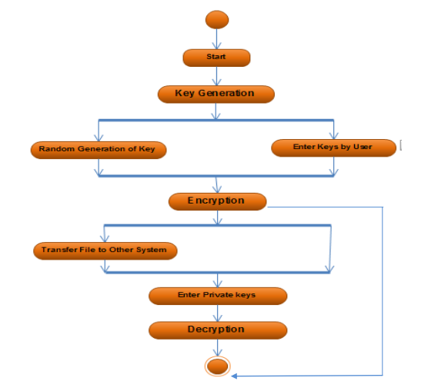

**Chapter 4 Implementation Planning**

**4.1 Implementation Environment**

It is a GUI based application. It is carried out in an IDE. Android Studio is one of them.

**Android Studio** is the official integrated development environment (IDE) for Google's Android operating system, built on JetBrains' IntelliJ IDEA software and designed specifically for Android development.

**4.2 Coding Standards**

* Sample code of the program:

**GUI CODE: Main Activity.xml**

*<?***xml version="1.0" encoding="utf-8"***?>*<**android.support.constraint.ConstraintLayout xmlns:android="http://schemas.android.com/apk/res/android"  
 xmlns:app="http://schemas.android.com/apk/res-auto"  
 xmlns:tools="http://schemas.android.com/tools"  
 android:layout_width="match_parent"  
 android:layout_height="match_parent"  
 android:background="#FFFFFF"  
 tools:context=".MainActivity"**>  
  
 <**ImageView  
 android:id="@+id/imageView"  
 android:layout_width="match_parent"  
 android:layout_height="match_parent"  
 android:scaleType="centerCrop"  
 android:src="@drawable/grjml"  
  
 app:layout_constraintEnd_toEndOf="parent"  
 app:layout_constraintStart_toStartOf="parent"  
 app:layout_constraintTop_toTopOf="parent"** />  
  
 <**Button  
 android:id="@+id/Textv"  
 android:layout_width="300dp"  
 android:layout_height="90dp"  
 android:layout_marginTop="30dp"  
 android:onClick="switchAlgho"  
 android:text="Advanced Encryption Standard"  
 android:textColor="#000000"  
 android:textSize="20dp"  
 app:layout_constraintEnd_toEndOf="parent"  
 app:layout_constraintHorizontal_bias="0.5"  
 app:layout_constraintStart_toStartOf="parent"  
 app:layout_constraintTop_toTopOf="parent"** />  
  
  
 <**EditText  
 android:id="@+id/edit"  
 android:layout_width="300dp"  
 android:layout_height="160dp"  
 android:layout_marginBottom="405dp"  
 android:background="#FFFFFF"  
 android:gravity="center"  
 android:hint="Enter your message here"  
 android:inputType="textMultiLine"  
 android:textColor="#000000"  
 android:textSize="15dp"  
 app:layout_constraintBottom_toBottomOf="parent"  
 app:layout_constraintEnd_toEndOf="parent"  
 app:layout_constraintHorizontal_bias="0.5"  
 app:layout_constraintStart_toStartOf="parent"** />  
  
  
 <**EditText  
 android:id="@+id/Key"  
 android:layout_width="130dp"  
 android:layout_height="50dp"  
 android:layout_marginBottom="340dp"  
 android:background="#FFFFFF"  
 android:gravity="center"  
 android:hint="key"  
 android:maxLength="10"  
 android:paddingTop="5dp"  
 android:paddingBottom="5dp"  
 android:textColor="#000000"  
 android:textSize="15dp"  
 app:layout_constraintBottom_toBottomOf="parent"  
 app:layout_constraintEnd_toEndOf="parent"  
 app:layout_constraintHorizontal_bias="0.5"  
 app:layout_constraintStart_toStartOf="parent"** />  
  
  
 <**TextView  
 android:id="@+id/EncDec"  
 android:layout_width="300dp"  
 android:layout_height="160dp"  
 android:layout_marginBottom="100dp"  
 android:background="#FFFFFF"  
 android:gravity="center"  
 android:hint="Your output gonna be here"  
 android:inputType="textMultiLine"  
 android:textColor="#000000"  
 android:textSize="15dp"  
 app:layout_constraintBottom_toBottomOf="parent"  
 app:layout_constraintEnd_toEndOf="parent"  
 app:layout_constraintHorizontal_bias="0.5"  
 app:layout_constraintStart_toStartOf="parent"** />  
  
 <**TextView  
 android:id="@+id/EncDecmat"  
 android:layout_width="217dp"  
 android:layout_height="111dp"  
 android:layout_marginBottom="160dp"  
 android:background="#FFFFFF"  
 android:gravity="center"  
 android:hint="Your Matrix Key gonna be here"  
 android:inputType="textMultiLine"  
 android:textColor="#000000"  
 android:textSize="15dp"  
 app:layout_constraintBottom_toBottomOf="parent"  
 app:layout_constraintEnd_toEndOf="parent"  
 app:layout_constraintHorizontal_bias="0.5"  
 app:layout_constraintStart_toStartOf="parent"** />  
  
 <**TextView  
 android:id="@+id/EncDecenc"  
 android:layout_width="300dp"  
 android:layout_height="56dp"  
 android:layout_marginBottom="95dp"  
 android:background="#FFFFFF"  
 android:gravity="center"  
 android:hint="Your output gonna be here"  
 android:inputType="textMultiLine"  
 android:textColor="#000000"  
 android:textSize="15dp"  
 app:layout_constraintBottom_toBottomOf="parent"  
 app:layout_constraintEnd_toEndOf="parent"  
 app:layout_constraintHorizontal_bias="0.5"  
 app:layout_constraintStart_toStartOf="parent"** />  
  
  
 <**Button  
 android:id="@+id/encbut"  
 android:layout_width="111dp"  
 android:layout_height="60dp"  
 android:layout_marginBottom="272dp"  
 android:onClick="Encrypt"  
 android:text="Encrypt"  
 android:textSize="19dp"  
 app:layout_constraintBottom_toBottomOf="parent"  
 app:layout_constraintEnd_toEndOf="parent"  
 app:layout_constraintHorizontal_bias="0.25"  
 app:layout_constraintStart_toStartOf="parent"** />  
  
 <**Button  
 android:id="@+id/decbut"  
 android:layout_width="111dp"  
 android:layout_height="60dp"  
 android:layout_marginBottom="272dp"  
 android:onClick="Decrypt"  
 android:text="Decrypt"  
 android:textSize="19dp"  
 app:layout_constraintBottom_toBottomOf="parent"  
 app:layout_constraintEnd_toEndOf="parent"  
 app:layout_constraintHorizontal_bias="0.75"  
 app:layout_constraintStart_toStartOf="parent"** />  
  
 <**Button  
 android:id="@+id/button"  
 android:layout_width="111dp"  
 android:layout_height="60dp"  
 android:layout_marginBottom="32dp"  
 android:onClick="copyToClipboard"  
 android:text="Copy"  
 android:textSize="20dp"  
 app:layout_constraintBottom_toBottomOf="parent"  
 app:layout_constraintEnd_toEndOf="parent"  
 app:layout_constraintHorizontal_bias="0.25"  
 app:layout_constraintStart_toStartOf="parent"** />  
  
 <**Button  
 android:id="@+id/button2"  
 android:layout_width="111dp"  
 android:layout_height="60dp"  
 android:layout_marginBottom="32dp"  
 android:onClick="RESET"  
 android:text="RESET"  
 android:textSize="20dp"  
 app:layout_constraintBottom_toBottomOf="parent"  
 app:layout_constraintEnd_toEndOf="parent"  
 app:layout_constraintHorizontal_bias="0.75"  
 app:layout_constraintStart_toStartOf="parent"** />  
  
 <**TextView  
 android:id="@+id/textView"  
 android:layout_width="wrap_content"  
 android:layout_height="17dp"  
 android:layout_marginBottom="8dp"  
 android:text="Made By: Tapas Vashi"  
 app:layout_constraintBottom_toBottomOf="parent"  
 app:layout_constraintEnd_toEndOf="parent"  
 app:layout_constraintStart_toStartOf="parent"** />  
  
 <**android.support.constraint.Guideline  
 android:id="@+id/guideline"  
 android:layout_width="wrap_content"  
 android:layout_height="wrap_content"  
 android:orientation="vertical"  
 app:layout_constraintGuide_begin="20dp"** />  
  
 <**android.support.constraint.Guideline  
 android:id="@+id/guideline2"  
 android:layout_width="wrap_content"  
 android:layout_height="wrap_content"  
 android:orientation="horizontal"  
 app:layout_constraintGuide_begin="20dp"** />  
  
 <**android.support.constraint.Group  
 android:id="@+id/group"  
 android:layout_width="wrap_content"  
 android:layout_height="wrap_content"** />  
  
 <**android.support.constraint.Guideline  
 android:id="@+id/guideline3"  
 android:layout_width="wrap_content"  
 android:layout_height="wrap_content"  
 android:orientation="vertical"  
 app:layout_constraintGuide_begin="20dp"** />  
  
  
</**android.support.constraint.ConstraintLayout>**

**Java Code: ceasercipher.java**

**package** com.example.encryptionDecryption;  
  
**public class** ceasercipher {  
 String **message**;  
 **char ch**;  
 **char NumbTest**[] = {**'0'**,**'1'**, **'2'**, **'3'**, **'4'**, **'5'**, **'6'**, **'7'**, **'8'**, **'9'**};  
 **public** String caesarcipherEnc (String message,**int** key){  
 String encryptedMessage = **""**;  
 **int** n = 1;  
 **for** (**int** i = 0; i < message.length(); i++) {  
 n = 1;  
 **ch** = message.charAt(i);  
 **for** (**int** j = 0; j < **NumbTest**.**length**; j++)  
 {  
 **if** (**ch** == **NumbTest**[j])  
 {  
  
 **if**((**char**)key+**ch**>**'9'**)  
 **break**;  
 **ch** = (**char**) (**ch** + key);  
 encryptedMessage += **ch**;  
 n = 0;  
 **break**;  
 }  
 }  
 **if** (n == 0)  
 {  
 **continue**;  
 } **else  
 if** (**ch** >= **'a'** && **ch** <= **'z'**)  
 {  
 **ch** = (**char**) (**ch** + key);  
  
 **if** (**ch** > **'z'**) {  
 **ch** = (**char**) (**ch** - **'z'** + **'a'** - 1);  
 }  
  
 encryptedMessage += **ch**;  
 } **else if** (**ch** >= **'A'** && **ch** <= **'Z'**) {  
 **ch** = (**char**) (**ch** + key);  
  
 **if** (**ch** > **'Z'**) {  
 **ch** = (**char**) (**ch** - **'Z'** + **'A'** - 1);  
 }  
  
 encryptedMessage += **ch**;  
 } **else** encryptedMessage += **ch**;  
 }  
  
 **return** encryptedMessage;  
 }  
 **public** String caesarcipherDec (String message,**int** key)  
 {  
 String decryptedMessage = **""**;  
 **int** n = 1;  
 **for** (**int** i = 0; i < message.length(); i++) {  
 n = 1;  
 **ch** = message.charAt(i);  
 **for** (**int** j = 0; j < **NumbTest**.**length**; j++) {  
 **if** (**ch** == **NumbTest**[j]) {  
  
 **if**((**char**)key+**ch**>**'9'**)  
 **break**;  
 **ch** = (**char**) (**ch** - key);  
 decryptedMessage += **ch**;  
 n = 0;  
 **break**;  
 }  
 }  
 **if** (n == 0)  
 {  
 **continue**;  
 } **else if** (**ch** >= **'a'** && **ch** <= **'z'**) {  
 **ch** = (**char**) (**ch** - key);  
  
 **if** (**ch** < **'a'**) {  
 **ch** = (**char**) (**ch** + **'z'** - **'a'** + 1);  
 }  
  
 decryptedMessage += **ch**;  
 } **else if** (**ch** >= **'A'** && **ch** <= **'Z'**) {  
 **ch** = (**char**) (**ch** - key);  
  
 **if** (**ch** < **'A'**) {  
 **ch** = (**char**) (**ch** + **'Z'** - **'A'** + 1);  
 }  
  
 decryptedMessage += **ch**;  
  
 } **else** decryptedMessage += **ch**;  
 }  
 **return** decryptedMessage;  
 }  
}

**4.3 Snapshots of project**

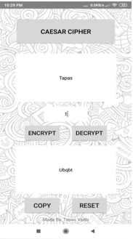

**Fig 4.2.1**

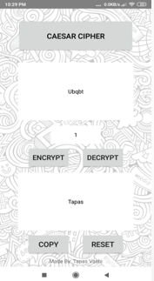

**Fig 4.2.2**

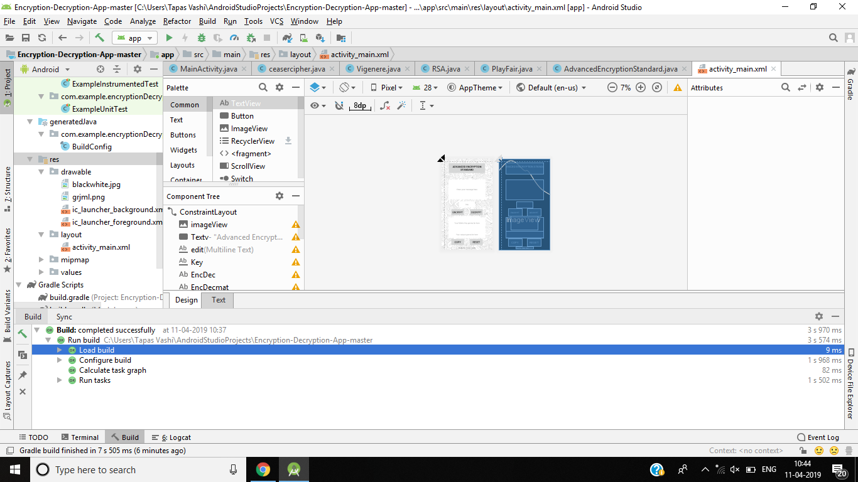

**Fig 4.2.3**

**Chapter 5: Limitations and Future Enhancement**

**5.1 Limitations**

* If we have firstly encrypted the data, then the same data can only be decrypted.
* For Eg; If we have encrypted the word “Tapas” and suppose encrypted text is “ubqbt” then, the same encrypted text i.e.. “ubqbt” need to be decrypted. If we try something different, it will show us an error.
  1. **Future Enhancement**
* Currently in my application we can only encrypt/decrypt text data. i.e.. we cannot encrypt/decrypt another data like images, videos, etc.
* So, I further look forward to build and implement such an app by which we can even encrypt and decrypt images and videos also.

**Chapter 6 :Conclusion**

* In this project I have successfully made an application by which we can easily encrypt and decrypt data using various encryption and decryption algorithms.

It can be used by the government of a country so that the task of various national policy formulation and international trade may proceed smoothly. It can also be used by banks so that the task of amount transfer, amount withdrawal or balance enquiry, etc. can be done without the fear of losing the password. It can even be used by various websites so as to keep the password and other private entities of the user secure .

**References:-**

* [**https://www.researchgate.net/publication/323847160_MESSAGE_ENCRYPTION_AND_DECRYPTION_ON_MOBILE_PHONES**](https://www.researchgate.net/publication/323847160_MESSAGE_ENCRYPTION_AND_DECRYPTION_ON_MOBILE_PHONES)
* [**https://link.springer.com/chapter/10.1007/978-3-642-27948-5_23**](https://link.springer.com/chapter/10.1007/978-3-642-27948-5_23)
* [**http://www.academia.edu/Documents/in/Encryption_and_Decryption**](http://www.academia.edu/Documents/in/Encryption_and_Decryption)